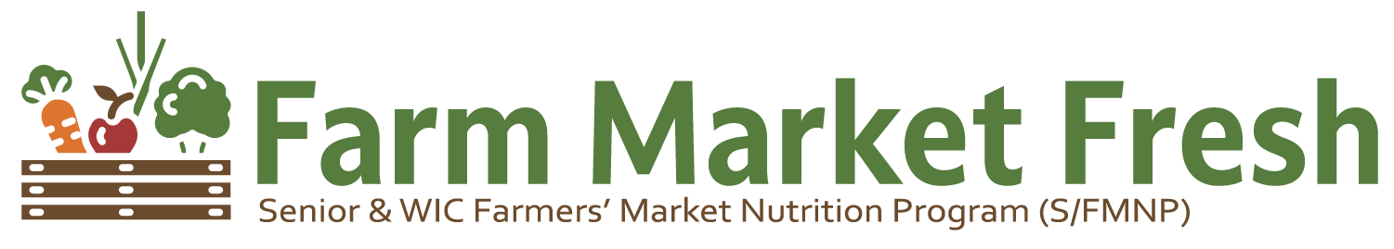We proudly accept S/FMNP

for local, seasonal fruits, vegetables & herbs

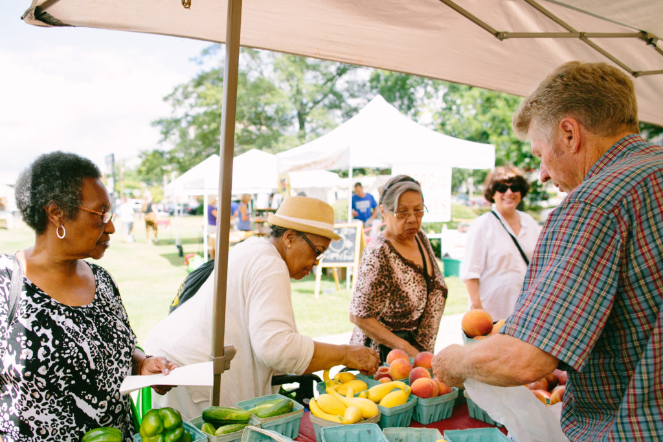
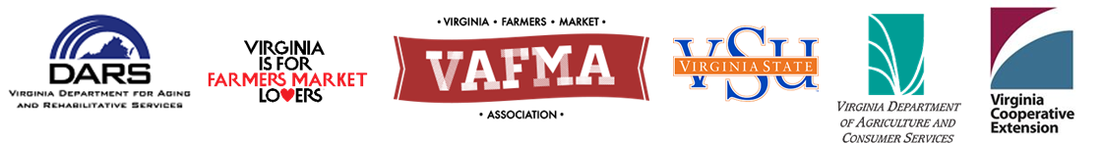
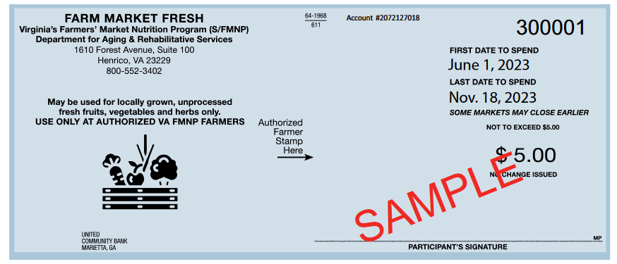
Use your Senior & WIC Farmers’ Market Nutrition Program Checks Here!

